Linux Programming: Assignment-8:

- What is a user-defined function in shell scripting? Explain with an example.
- A user-defined function in shell scripting is a block of code that you create to perform a specific task.
- We define it ourself (hence “user-defined”) and can call it multiple times in your script without rewriting the same code.
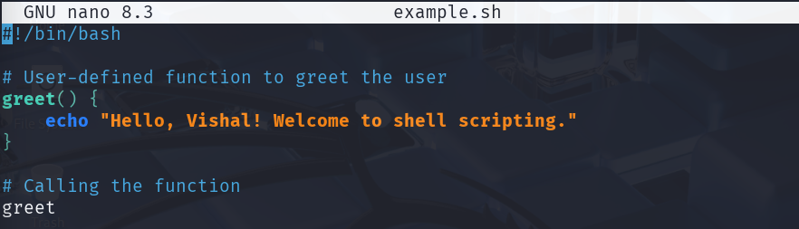

- Write a bash script with a function that multiply two integer numbers.
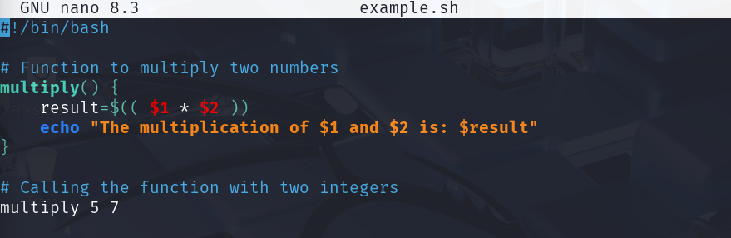

- Explain how arrays (1D, 2D, and 3D) are declared in bash scripting.
- 1D array

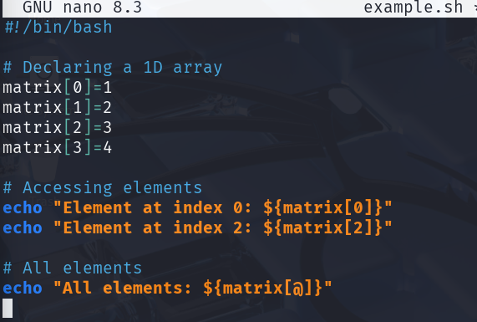
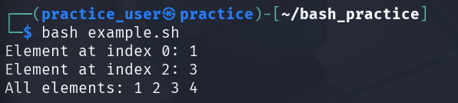

- 2D array

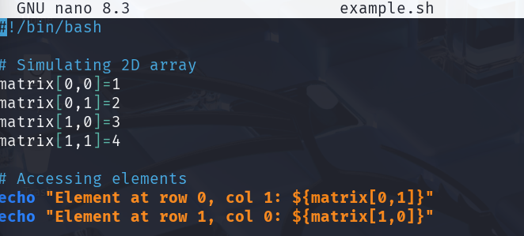

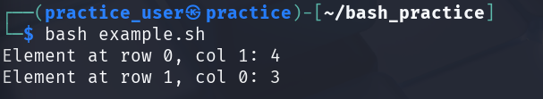

- 3D array

- Write a shell script to display elements of an array
#!/bin/bash

# Declare an array
fruits=("Apple" "Banana" "Cherry" "Mango")

# Display all elements using a loop
echo "Elements of the array are:"
for fruit in "${fruits[@]}"
do
echo "$fruit"
done

- What is the purpose of cron in Linux?
- The purpose of “cron” in Linux is to schedule and automate tasks that need to run at specific times or intervals.
- It’s a background service (daemon) that executes commands or scripts automatically according to a predefined schedule, so you don’t have to run them manually.
- Tasks are defined in a crontab file, which contains timing rules and commands.
- Cron is used for repetitive tasks, like backups, updates, or sending emails.
- The script runs even if we are not logged in.

- Write a cron job to run a backup script every day at midnight.
- Assume we created a script called “midnight_reminder.sh” which will display a goodnight message to me everyday at midnight.

#!/bin/bash

message="Goodnight, Vishal! It's time to sleep "

# Print message to terminal (if running in terminal)
echo "$message"

# Save message to a log file
echo "$(date): $message" >> /home/user/midnight_reminder.log

- And we want to make this script run everyday at midnight so,
- We would make the file executable using ,
“chmod +x /home/user/midnight_reminder.sh”

- Then we would open the crontab using, “crontab -e”

- Then would add the execution info to the cron table like

“0 0 * * * /home/user/midnight_reminder.sh”

- Thus, at midnight 00:00 everyday, it runs the script and prints the message in the terminal and the logfile is updated with a timestamp.

- How do you schedule a one-time job using at command?
- The at command in Linux is used to schedule a one-time task at a specific time and unlike cron, it only runs once.

- Suppose we want the previous script to run at 10:30 pm today once so, we would write:

- at 22:30
- /home/user/midnight_reminder.sh

#then press Ctrl+D to save and exit .

- Write a script to display disk usage using df and du.
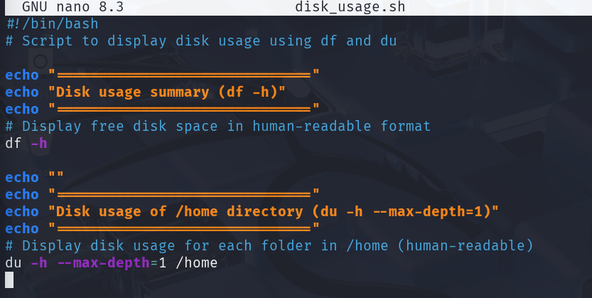

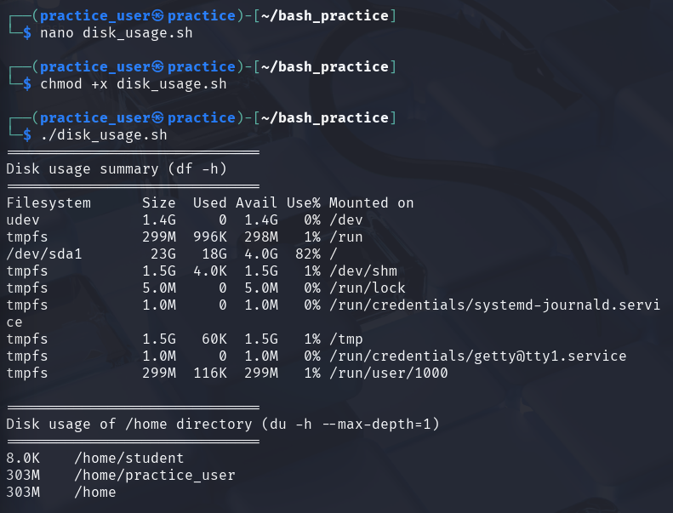
- “df -h” Shows overall disk space usage of all mounted filesystems in a human-readable format (e.g., MB, GB).

- “du -h” shows disk usage of each subdirectory inside /home.
- --max-depth=1 ensures it doesn’t recurse too deep, so it shows only top-level directories.
- And the -h flag shows output in human readable format.

- How can you log the output of a script using the tee command?
- ./script.sh | tee script.txt

- By this the output will be shown and at the same time it would be saved to the script.txt

- Explain with an example how shell scripting can automate system administration tasks.
    - System administrators need to monitor disk usage regularly to avoid full disks, which can cause system crashes or application failures.
    - Instead of manually running “ df -h “every day, a shell script can automatically check disk space, save the output to a file, and even alert if space is low.

    - As shown in example no. 8, if we just add the script to be automated to the cron table by,

crontab -e
0 0 * * * /home/user/disk_usage.sh

- Thus, at midnight 00:00 everyday, it runs the script and prints the message in the terminal and the logfile is updated with a timestamp.
Therefore, the system administrator can see the disk space at midnight without the need of typing dh -f and if he misses that , he can check it in the log file anyhow.

